(Approx. 1240 words)

Organizational Communication
Author: Dick Maybach, Member, Brookdale Computer User Group, NJ
www.bcug.com
n2nd (at) att.net

A major responsibility of any organization is to provide communication both among its members and with those outside. There are many ways to accomplish this, including:
- newsletters,
- mass e-mailings,
- Websites,
- Facebook and other social media,
- computer bulletin boards,
- face-to-face meetings, and
- voice and video conferences.

Years ago printed newsletters were very important, but high printing and mailing costs have all but eliminated them. Many clubs now publish newsletters on their Website usually as PDFs, making them easier to print than Website pages. Because accessing issues usually requires several clicks, they are less effective than Websites in attracting new members and reminding current ones of upcoming events. They excel in communicating technical information, which often requires study or a paper copy that can be consulted when a PC isn’t available. Website newsletter archives make back issues available, making them far more useful than their printed predecessors, but finding information can be tedious unless they are indexed.

Mass e-mail is a good method for announcements, such as meeting reminders and schedule changes. Meetings often don’t occur on a fixed schedule, and without reminders, many members will miss them. As with all communications, restraint is important. I get over 40 e-mails a day, and messages from those sending too many go directly to a spam folder.

A well-designed Website is valuable, both for keeping members informed and attracting new ones. Besides making the site available, most hosts collect user statistics that can help gauge its effectiveness by providing such valuable data as

- pages viewed,
- files downloaded,
- number of visitors and how long they stayed,
- viewers’ locations,
- searches made, and
- whether they were using a PC or a phone.

Studying these data can tell you much about how effective your site is. For example, on one I manage 72 percent of the visits lasted less than 30 seconds, and only seven percent longer than 15 minutes. I concluded that many visit only the home page, and that was my only chance to get members to the next meeting or entice non-members to join. They might click once if the button were really obvious, but few would take the time to do more. As a result, the home page must have enough information about the upcoming events to attract both current members and prospective ones, although some might take the time to click a “details” button. This space also shows members what activities they missed and others that this is an active organization they should consider. Again, there is space only or a short teaser, with details available after a single click.

A club’s Website requires daily maintenance, as leaving old information on it implies that the organization is inactive. I recommend Steve Krug’s, Don’t Make Me Think, Revisited as a guide. It says nothing about HTML coding, but a lot about how an effective site looks.

Figure 1 shows the site I manage, designed while keeping in mind that I must communicate my message in less than 30 seconds.

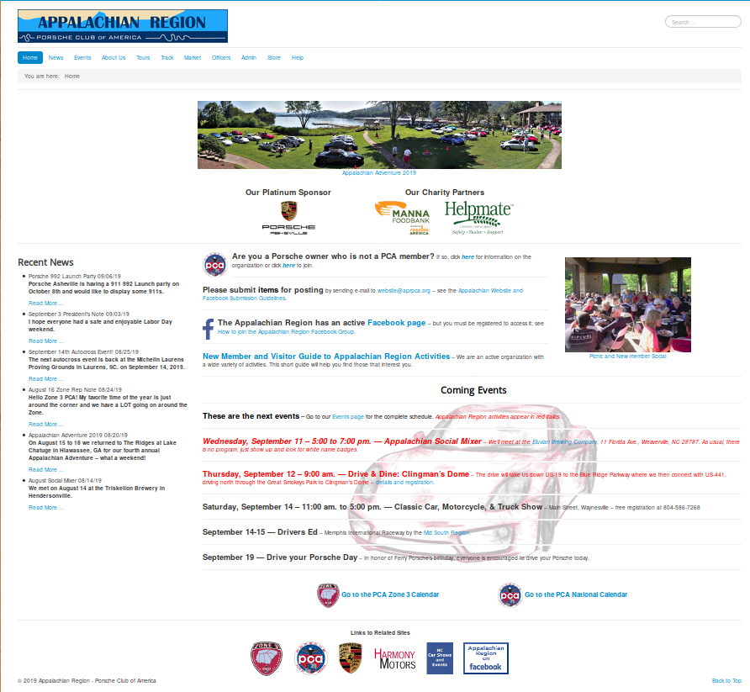
Figure 1. A Website for Busy Viewers.

The two photos are links that take the viewer to descriptions and pictures of recent events. The three logos near the top are links to the club’s sponsor and two charities it supports. Four items in bold text provide links to information on how to join the organization, a plea for members to submit articles, instructions on joining its Facebook group, and information on its activities. Below is a list of upcoming events, most with links to more details. On the left sidebar are teasers with links to articles on recent activities. Finally, at the bottom are links to some related sites. There are also some navigation aids (a menu, a search window, and a “You are here” box), but few 30-second viewers will notice these. Finally, although currently, only about five percent of the visits are via cell phones, this will most likely increase, and keeping the home page simply means these users can view it without frustration.

Figure 2 shows how not to do it. (I’ve blurred the site’s identifying information.)

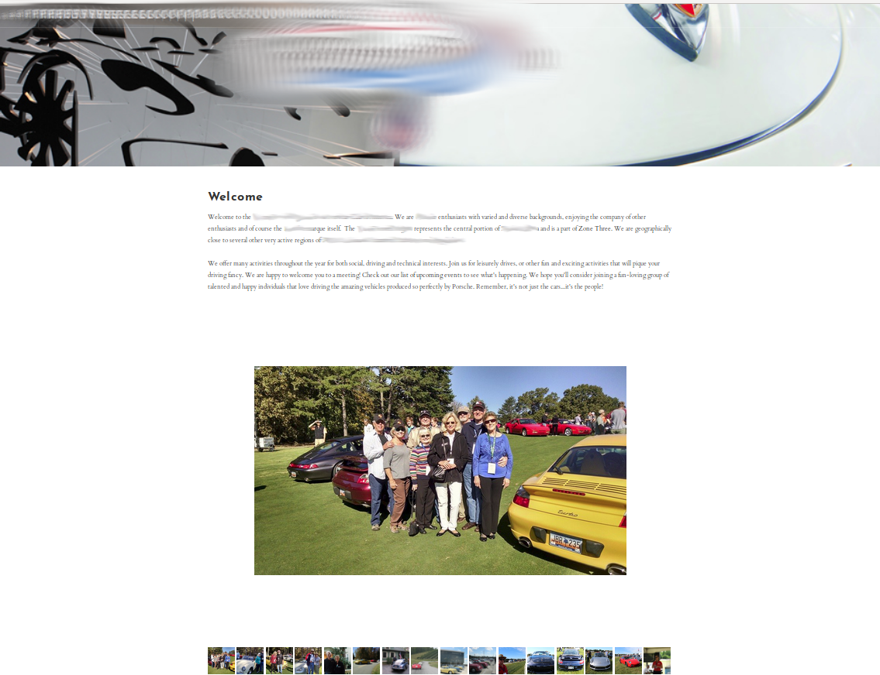
Figure 2. An Ineffective Website.

Except for the name of the organization, there is little information here. The only thing viewers learn about the club is that its members own nice cars.

While you can build a site using only HTML, a framework such as WordPress, Joomla, or Drupal makes it easy to add valuable features such as content search, navigation, calendar functions, and meeting registration. This complexity will take time to master and make it more difficult to transfer the job to someone else but documenting what you do will ease both tasks.

The site’s host can provide substantial help, such as providing the visitor statistics I’ve already mentioned. Many also will back up your site and host e-mail accounts for your officers, which allows them to place contact information on a site without exposing their private e-mail account.

While a Website or newsletter acts as the official voice of your organization, a bulletin board or Facebook page provides member-to-member communication. (I’m using “Facebook” here as a synonym for all social media.) There is a risk; for example, an intemperate rant against a vendor on your club’s page can be interpreted to be club policy. You may wish to allow only members to post to or even to access the page. Facebook has advantages over a bulletin board, in that it allows graphic content and can provide content search. It also collects user statistics, which as in the case of a Website, can tell you how effective the service is. Regardless, you must monitor the site continually to be sure it presents a positive view of the organization. Figure 3 shows a Facebook page.

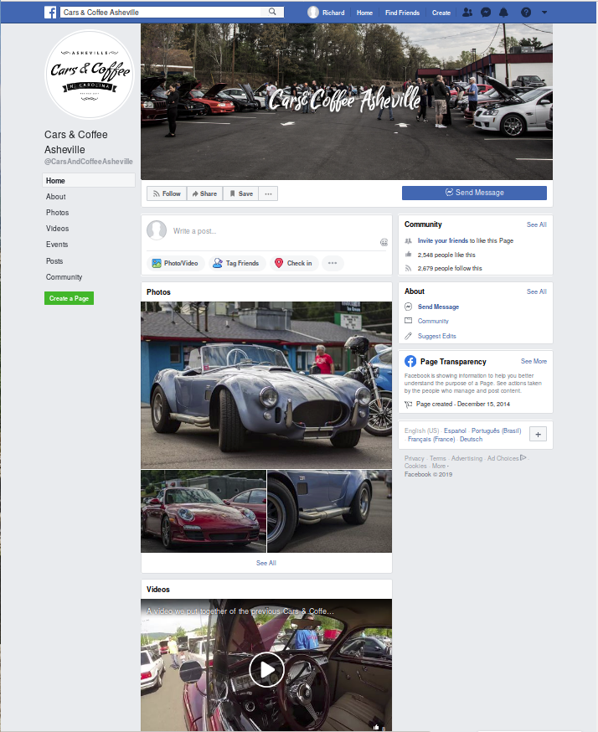
Figure 3. A Facebook Page.

My only criticism is that it’s lacking a search feature, which is very helpful as the articles appear in the order they were received. This organization has no Website and finding the time and place of their next meeting requires tedious searching, making it ineffective for recruiting new members. Choose your communications goals first and then your media, rather than selecting a medium you like and hoping it does what you want.

Face-to-face meetings are essential for most organizations. They allow free two-way communication and provide social bonding like no other forum. They do require travel, which can be difficult for some members, especially at night or in bad weather. Consider making these available as video conferences or podcasts for those who can’t attend in person. If they can be recorded, even those with schedule conflicts can see what happened, although they can’t participate. Effective meetings have a single purpose. Those interested in preventing malware attacks don’t care about which checks have cleared the club account. Details of club business are better handled in separate meetings, open to all members of course, and with their minutes posted on the club’s Website or Facebook page.

It’s important to measure the effectiveness of your communications, especially after making changes. Too often, these are set up and then ignored. If few of your members check your Facebook page, you should either improve or eliminate it. Ask a non-member to look at your media and tell you his or her impression; then act on it. Finally, periodically review your performance against your goals. If you can’t find any improvements, you aren’t trying hard enough.

